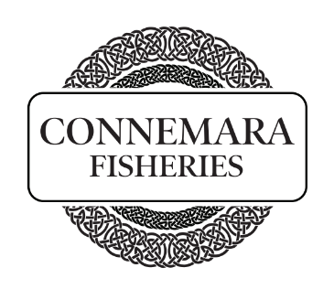
General Operative: A full-time role Monday – Friday
The duties will include
- Fish filleting, and pin boning
- Picking orders
- Cleaning down wet room
- Working as part of the team in smoked salmon production
- Filling in for van drivers as required
Start Date: As soon as possible
Who we are: Connemara Fisheries is based in Cornamona, Connemara, within the Gaeltacht region. The smokehouse is on the shoreline of Lough Corrib which feeds the River Corrib flowing into Galway Bay. We source only the best raw material for smoking. The premium product we source ensures our Smoked Salmon is simply delicious. We smoke all our Salmon onsite at our fully approved premises in Cornamona, factory approval number GY0102EC. The business also has a distribution side of fresh and frozen fish to hotels and restaurants in the region. Visit our website for further information https://connemarafisheries.com/

Benefits:
- Loyalty bonus
- Further training and development opportunities
- Working with a small team in a beautiful part of the country, producing a premium quality product.

Applicant minimum requirements:
- Ability to commute/relocate to Cornamona, Co. Galway
- Fluent English, written and spoken
- Full Driving Licence
If genuinely interested, please call Tommy on 087648859 or send your CV to connemarasalmonqueries@gmail.com

