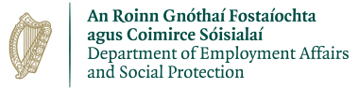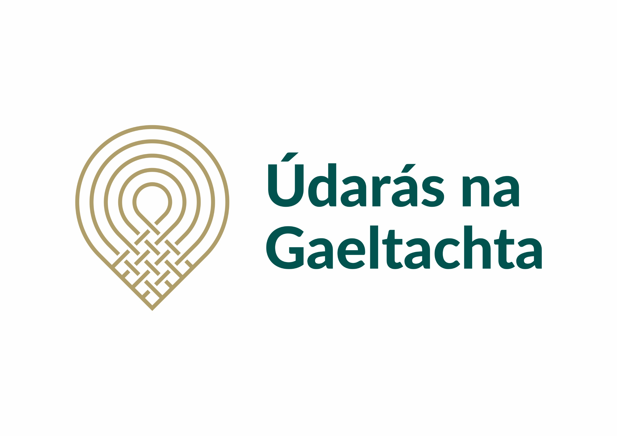

Rural Social Scheme Supervisor - Maor Scéim Sóisialta Tuaithe

Tá post mar shaoiste lánaimseartha á lorg do Scéim Sóisialta Tuaithe i gCorca Dhuibhne. Tagann an maoiniú don bpost seo ón Roinn Gnóthaí Fostaíochta agus Coimirce Sóisialaí. Beidh an té a cheapfar lonnaithe i gCorca Dhuibhne.
We are recruiting a Rural Social Scheme Supervisor in West Kerry; this is a full-time position. The funding for this role comes from the Department of Employment Affairs and Social Protection.

Tá sé riachtanach go mbeadh na scileanna//tréithe/ taithí seo a leanas ag iarratasóirí don phost.
Necessary Requirements:
- Taithí mhaoirseachta bainistiú daoine 2 bhliain ar a laghad /minimum 2 years supervisory / management experience.
- Sárscileanna riaracháin agus eagrúcháin / Excellent administration and organisational skills
- Tuiscint ar chúrsaí Sláinte agus Sábháilteacht / Health and Safety knowledge
- Sárscileanna idirphearsanta agus cumarsáide / Excellent Communication Skills
- Scileanna ríomhaireachta / Excellent computer skills.
- Ceadúnas iomlán glan tiomána/córas iompair / Full clean driving licence
- Gaeilge Labhartha chomh maith le cumas scríobh na Gaeilge. / Spoken and written Irish

Seachtain oibre 39 uair a chloig Luan go hAoine a bheidh á thairiscint. Tá tuarastal bunaithe ar scála pá ag tosú ar pointe 1 don scála c.c €33,551.64. Salary scale starting at point 1 c.c €33,551.64 for a 39-hour week Monday to Friday.
Seoltar iarratas, mar aon le Curriculum Vitae roimh 5.00 i.n. Dé Céadaoin 2 Iúil 2025 chuig am@udaras.ie Applications to am@udaras.ie no later than 5.00p.m Wednesday 2 July 2025.
Breis eolas ó Anne Marie ar 066 9150100 – Further information from Anne Marie 066 9150100

Is fostóir comhdheiseanna é Údarás na Gaeltachta agus is í an Ghaeilge a theanga oibre.

