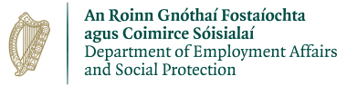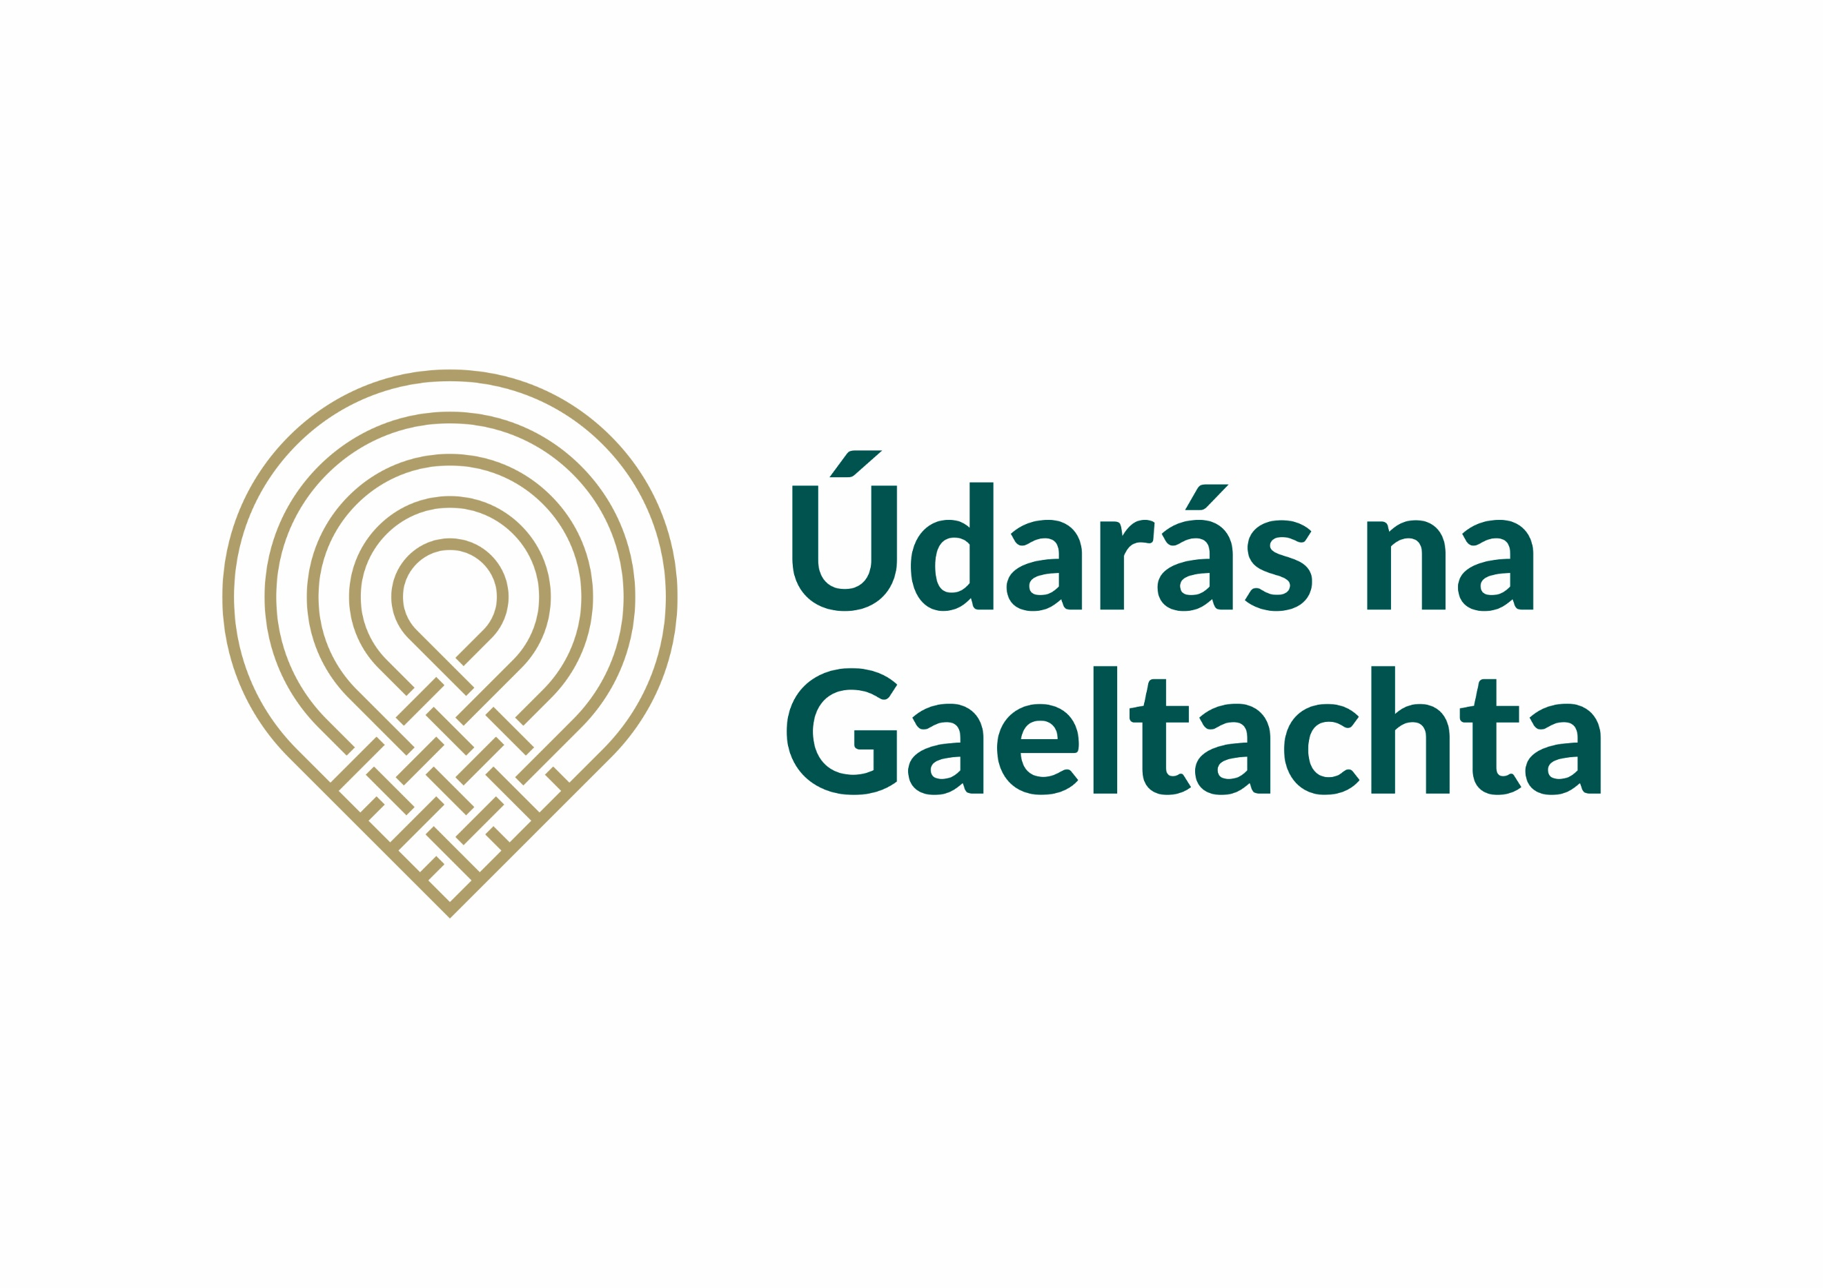

Rural Social Scheme Supervisor - Maor Scéim Sóisialta Tuaithe
Gaeltacht Chiarraí Theas / South Kerry Gaeltacht
Tá post mar shaoiste lán aimseartha á lorg do Scéim Sóisialta Tuaithe Gaeltacht Ciarraí Theas. Tagann an maoiniú don bpost seo ón Roinn Gnóthaí Fostaíochta agus Coimirce Sóisialaí. Beidh an té a cheapfar lonnaithe i gCiarraí Theas. The position will be based in South Kerry.
We are recruiting a full time Rural Social Scheme Supervisor in the South Kerry Gaeltacht.. The funding for this role comes from the Department of Employment Affairs and Social Protection.

Tá sé riachtanach go mbeadh na scileanna//tréithe/ taithí seo a leanas ag iarratasóirí don phost.
Necessary Requirements:
- Taithí mhaoirseachta bainistiú daoine 2 bhliain ar a laghad /minimum 2 years supervisory / management experience.
- Sárscileanna riaracháin agus eagrúcháin / Excellent administration and organisational skills
- Tuiscint ar chúrsaí Sláinte agus Sábháilteacht / Health and Safety knowledge
- Sárscileanna idirphearsanta agus cumarsáide / Excellent Communication Skills
- Scileanna ríomhaireachta / Excellent computer skills.
- Ceadúnas iomlán glan tiomána/córas iompair / Full clean driving licence
- Gaeilge Labhartha chomh maith le cumas scríobh na Gaeilge. / Spoken and written Irish

Seachtain oibre 39 uair a chloig Luan go hAoine a bheidh á thairiscint. Tá tuarastal bunaithe ar scála pá ag tosú ar pointe 1 don scála c.c €33,551.64. Salary scale starting at point 1 c.c €33,551.64 for a 39-hour week Monday to Friday.
Seoltar iarratas, mar aon le Curriculum Vitae roimh 5.00 i.n. Dé hAoine 29ú Lúnasa 2025 chuig am@udaras.ie Applications to am@udaras.ie no later than 5.00p.m Friday 29th August 2025.
Breis eolas ó Anne Marie ar 066 9150100 – Further information from Anne Marie 066 9150100

Is fostóir comhdheiseanna é Údarás na Gaeltachta agus is í an Ghaeilge a theanga oibre.

