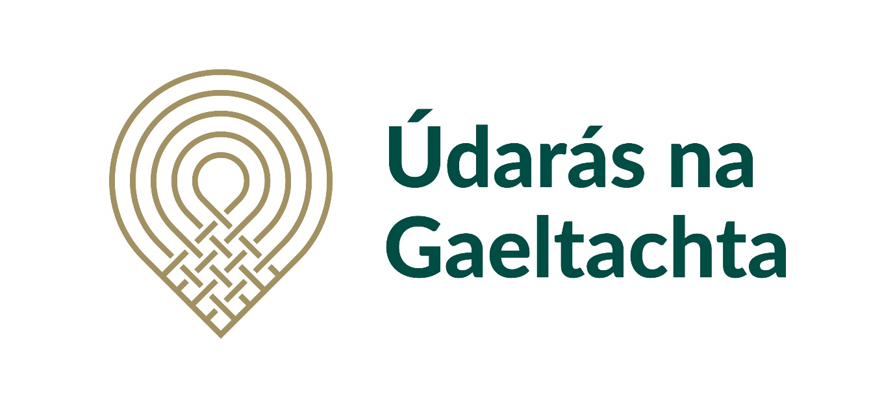

Údarás na Gaeltachta
Graduate Scholarship Research Programme

2025

Closing Date: 27 June 2025
Note: Applications will only be accepted from Universities/Third Level Institutions/Research Institutes
Conditions: Any student undertaking research who is not fluent in the Irish language will be required to complete the European Certificate in Irish Language (TEG) at an appropriate level.

Part 1- Contact Details
1. | University/ Institute:
2. | Contact:
3. | E-mail:
4. | Title/Role in the organisation:

Part 2 – Other Partners
5. Does the University/Institute intend to conduct the research in conjunction with another partner?
☐ Yes
☐ No
If Yes, please give details as follows:
6 | Name of Partner:
7. | Contact Details:
8. | E-mail:
9. | Title/Role in the organisation:

10. If so, please include a letter of support from the Partner.
Part 3 – The Research Programme
11. Details of the type of Postgraduate research:

Masters Research Degree (12 months)
Masters Research Degree (24 months)
Structured Masters Research Degree (12 months)
Structured Masters Research Degree (24 months)
Traditional Doctorate (36 months)
Traditional Doctorate (48 months)
Structured Doctorate (36 months)
Structured Doctorate (48 months)
PhD (36 months)
PhD (48 months)
Does a term of work experience apply?
Other

12. What sector/subject is the focus of the research? You may choose more than one option below.
Sector/Subject
☐ Community and Language
☐ Marine Development
☐ Enterprise Development
☐ Digitisation and Technology
☐ Rural Development
☐ Artificial Intelligence
☐ Community/Social Enterprise
☐ Cultural Tourism
☐ Sustainability
☐ Other

13. These research areas identified in question 12 refer to the sectors with the most potential for development within the Gaeltacht and which align closely with Údarás na Gaeltachta’s Development Strategy. Please give a brief overview of the aims of the research and how they correspond with the current Údarás na Gaeltachta Strategy. (max 500 words)

14. Give details of the key issues that will be central to the research and the objectives of the research project. (Max 500 words)

15. Summarise the literature that has been published to date on the research subject matter that will be used to inform and act as a reference for this project. (Max 500 words)

16. Give details on how this research will contribute to promoting the work of your organisation and that of Údarás na Gaeltachta or how it will support previous research completed in this area. (Max 500 words)

Part 4 – Methodology
17. Outline the research structure and methodologies which will be used in completing the research project. For example, focus group/population, measures being used or developed, proposed interventions or comparisons to be carried out, for example, the use of developing technologies, number of participants, interviews, focus groups. (Max 500 words)

18. Give an overview of the proposed method of gathering, collating and analysing data. (Max 500 words)

19. Outline any ethical or GDPR implications that may arise as part of this proposed research (e.g. informed consent, recruitment, vulnerable populations, child protection). In the event that ethical or GDPR issues arise, outline briefly how these issues will be addressed during the research project. (Max 500 words)

20. Will it be necessary for the Institute’s Review Board or Ethics Committee to approve the research project prior to commencement?
☐ Yes
☐ No
Part 5 – Project Management
21. Give an overview of the professional experience/academic experience of the research mentor? (Max 500 words)

22. Give an overview of the project’s timelines and detail the objectives and outputs (including work experience, if applicable). Outline proposed dates in relation to each element/step of the research project.

23. Outline the risks that may impact the research project’s completion timeline. (Max 500 words)

24. Outline how effective cooperation will be maintained between all team members during the project (sharing resources/expertise, team meetings, access to data, roles and responsibilities etc.) Max 500 words

25. Outline how it is proposed to share the research once completed, i.e publications, media coverage, conference attendance, workshops and other activities. Max 500 words

26. Outline how recognition will be given to the Údarás na Gaeltachta Graduate Scholarship Programme. Max 500 words

Part 6 – Financing
The maximum annual funding available to be approved under the Scheme will not exceed €10,000
27. Give details of the planned expenditure for the research project. Any co-funding can be included in the total expenditure, including work experience, salary, fees and associated costs, if applicable. Max 500 words
Expenditure Headings | Údarás Funding | Other Funding | Overall Cost per annum
Year 1
Year 2 (if applicable)
Year 3 (if applicable)
Year 4 (if applicable)

Section 5- Signed Declaration
28. Have you completed and signed the Declaration Form as part of your application submission?
☐ Yes
☐ No

Please return this form to
Research and Sectoral Development Division
Graduate Scholarship Programme
Údarás na Gaeltachta
Baile an Mhuilinn
Co. Chiarraí

On or before 27 June 2025 or via e-mail: oiliuint@udaras.ie

