Expression of Interest
to inform the development of facilities
for the food sector

Date issued: 01st March 2022
Deadline for Expressions: 1st April 2022
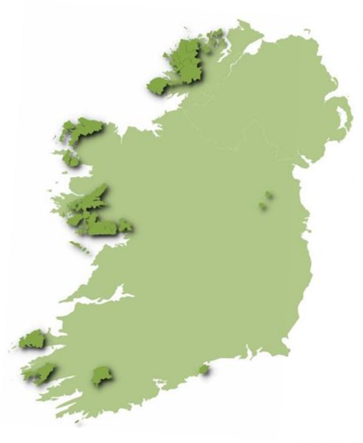
About Údarás na Gaeltachta and an Ghaeltacht
The overall objective of Údarás na Gaeltachta is to ensure that Irish remains the main communal language of the Gaeltacht (areas shaded in dark green) and is passed on to future generations. Údarás endeavours to achieve that objective by funding and fostering a wide range of enterprise development and job creation initiatives and by supporting strategic language, cultural and community-based activities. Údarás encourages investment in the Gaeltacht through a range of financial and non-financial incentives for new and existing enterprises in the Gaeltacht.

The organisation supports businesses in developing new markets, technologies, products and strategic alliances through research and development. Gaeltacht companies span a range of commercial sectors including – life sciences, ICT, tourism, fish processing and aquaculture, renewable energy, food, niche manufacturing, audio visual and digital media, arts and crafts.

The Gaeltacht is a vibrant and creative region unique in its language, history, culture, people and landscape. The region has an organic identity that instinctively lends itself to creating its own brand. With so much great activity originating in this very special region, Údarás na Gaeltachta has developed a unique identifier that can be used to promote this excellence to the wider world. The brand reflects the Gaeltacht, a region rich in terms of culture, language, education, enterprise, community spirit and natural beauty. The ‘Gaeltacht na hÉireann’ logo is a visual device that will help those in the region to tell their story and raise awareness nationally and internationally under a unified identity.
The vision is that the logo will be used on products, services and promotional materials and will be available to companies/organisations located within the Gaeltacht for use on their branded communications also.

Food production
One of the biggest challenges for food production businesses is finding premises suitable for food manufacture and fitting these out to meet legislative requirements. Údarás na Gaeltachta is assessing the potential of providing space aimed to nurture entrepreneurship and enterprise, providing a supportive environment in which new and existing business can commercialise their business ideas.
Under the Gaeltacht na hÉireann brand Údarás na Gaeltachta invites expressions of interest (EOI) from potential project promoters in the food sector who may be interested in establishing a presence at a food hub across the Gaeltacht.
Objectives
The purpose of this EOI is to assist Údarás na Gaeltachta in preparing a suitable development plan and:
- To assess the demand for food preparation, manufacturing, testing, packaging, facilities.
- To provide an opportunity for private individuals, enterprises (including social enterprises), public agencies to contribute to and/or participate in the development of enterprise space, commercial kitchen space and commercial rental opportunities for proposed hubs.
- To inform the overall design of the hubs which will be planned, developed, resourced and managed so as to encourage synergies and efficiencies in developing the food sector locally and on a regional basis.
- To assist in identifying specialised requirements amongst prospective clients that could inform the planning and the resourcing of facilities and infrastructure.
- To identify requirements in the food community for food uses that complement the core objectives relating to the planning of such facilities.
- To identify potential suitable employment creating projects, developed through public and private investment, in the food sector which could be developed at these hubs.
The recommended development of food hubs across the Gaeltacht can be expected to have the following impacts:
- Encouraging more start-ups by incubation including access to educational, training and research programs.
- Faster and larger scaling of existing Small and Medium-Sized Enterprises (SMEs) through access to shared infrastructure and facilitation of business development opportunities.
- Increased employment encouraging greater settlement in Gaeltacht areas.
- Increased demand for goods and services generally.

Submission Instructions
Respondents shall submit their Expressions of Interest by word document, as per appendix a, either by post or email to:
Máire Ní Éinniú
Development Executive,
Údarás na Gaeltachta,
Na Forbacha,
Co. na Gaillimhe.
H91 TY22
m.nieinniu@udaras.ie

For an informal discussion and for guidance on Expressions of Interest, please feel free to contact Máire Ní Éinniú, @ 091-503133 or m.nieinniu@udaras.ie

EOI Timetable

Issue Date of EOI | 1st March 2022
Submission Deadline Date | 1st April 2022
Submission Deadline Time | 17:00

The EOI timetable is tentative. It may be changed at any time. Údarás na Gaeltachta may choose to waive or extend the Submission Deadline.

EOI terms and conditions

Respondents must acknowledge, through their submission that this EOI and any respondent submissions shall not create a legal relationship between the respondent and Údarás na Gaeltachta or other, or any obligation by/on Údarás na Gaeltachta or other regarding the procurement of any good or service from a respondent.

These expressly reserved rights are in addition to any and all other rights of Údarás na Gaeltachta that existed prior to the issuance of this EOI.

Údarás na Gaeltachta makes no representation, warranty or guarantee as to the accuracy of the information contained in the EOI or issued by way of addenda. Any quantities shown or data contained in this EOI, or provided by way of addenda, are estimates provided only as general background information.

- Respondents to Bear Their Own Costs

The respondent shall bear all costs associated with or incurred in the preparation and presentation of their information, including, if applicable, costs incurred for interviews or demonstrations.

- Accuracy of Responses

The respondent acknowledges that the information provided in its Submission is, to the best of its knowledge, complete and accurate.

- Submissions Will Not Be Returned
Except where set out to the contrary in this EOI, or expressly requested in the respondent’s Submission, and agreed to by Údarás na Gaeltachta, the Submission provided by a respondent will not be returned.

- Confidential Information of Údarás na Gaeltachta
All information provided by or obtained from Údarás na Gaeltachta in any form in connection with this EOI either before or after the issuance of this EOI (i) is the sole property of Údarás na Gaeltachta and must be treated as confidential; (ii) is not to be used for any purpose other than replying to this EOI; and (iii) must not be disclosed without prior written authorisation from Údarás na Gaeltachta.

- Disclosure of Information
The respondent consents to Údarás na Gaeltachta collection of information as contemplated under the EOI. The confidentiality of such information will be maintained by Údarás na Gaeltachta, except where required by law, or an order by a tribunal, or court requires Údarás na Gaeltachta to do otherwise. The respondent consents to the disclosure, on a confidential basis, of this submission by Údarás na Gaeltachta to advisers retained by Údarás na Gaeltachta for the purpose of reviewing this submission.
Information Sheet
Name
Company name
Address *
Your email
Website (if applicable)
Where are you currently based?
*Please state if you are willing to travel to a facility located in a Gaeltacht area
Development stage, tick as appropriate
Idea
Proof-of-concept
Prototype
Technology readiness level
Already established (please state how long you are established)

Which best describes your product? Tick as appropriate
Consumer food
Fresh
Ambient
Dairy
Raw meat
Seafood
Frozen
Other – brief description

Which best describes your need? Tick as appropriate
Intake and despatch areas
Chilled and ambient storage
Changing rooms
Processing area
Temperature control systems
In house cleaning system
Production office
Other – brief description
Other challenge/need
Please describe
Please give an outline of your project
Number of employees envisaged and the types of jobs
Any training needs for employees/management
What soft skills are needed to allow your project to progress to the next stage? s
Such as mentoring support, financial planning assistance, market review etc.
What is your raw material, delivery arrangement, storage requirements, shelf life /transport movements
Brief description of space/equipment required i.e. floor area x height, office accommodation, production hall / food grade high / low risk zone, internal drainage, freezing etc., testing facilities, R&D space
Brief description of production process, fit out to intake area, production process, waste generated, storage / packing, daily wash down
Waste production (product) - external storage. Can your waste product be reused?
Design required for certification by Dept./Bodies

Any additional information or comment

